tumaini la maisha
annual report
2014
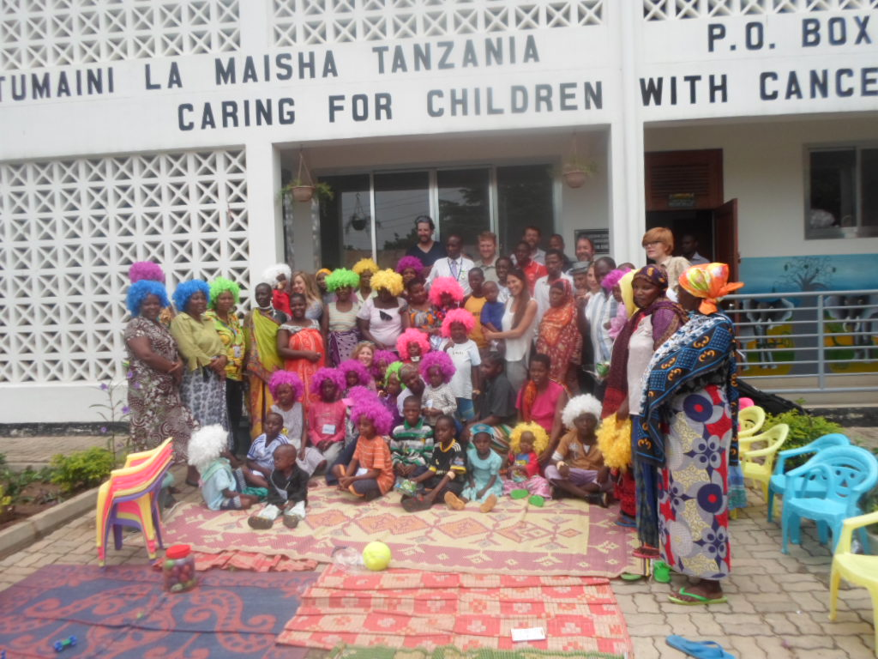
Tumaini La Maisha Annual Report January – December 2014

Introduction
This is the Annual Report, which sets forth the work done by the TLM team, Donor, Volunteers and Stakeholders in providing Non-Clinical services which reciprocate a way of working in the context of supporting children with cancer and their families.
This year, through working together with the stakeholders, both medical and non-medical we were able to identify the many needs of the children affected by childhood cancer and their families taking care of them during their treatment at Muhimbili National Hospital. We could only support so much, so we only undertook what we were equipped to support. We believe there is still room for improvement on our part and the coming year we aim for more in serving these children in the fight against childhood cancer.

A section has been added to give a first-hand understanding from the beneficiaries to share their personal experiences, in the hope that their compassion would serve as an inspiration to others and you reading this report.

Executive Summary
In the first quarter of new strategic year 2014, most of the programmes have been implemented with improvements made from lesson learnt in 2013. The year started with promising development of Nonclinical support programmes for the children with cancer and their families at the Hospital Ward and Ujasiri house.
The second quarter took place rather slowly due to the low number of inpatients and the focus was on strengthening and improving the programmes and introducing new programmes, such as the nutritional programme which further complimented further provision of nonclinical services to children with cancer and support their families. This was facilitated by in house trainings conducted by different specialists and the visit from our friends Love, Hope and Strength Organisation, CiC founder, amongst other greatly appreciated visitors.
The third quarter kick started by strong improvements in IGA programme which was designed to help parents increase their income earning and the skills development. The process which was pioneered by our partner The Impact Plan Org who supported parents IGA groups by enabling their handmade products have access to a bigger market in the United States of America as well as establishing a local market for the same.
Fourth Quarter saw the efforts being directed to the selected few programmes which remained. Challenges surfaced due to the limited number of staff, but also we were able to create partnership with other organizations generating a wide range provision of clinical and non-clinical support to children with cancer and their families. Impact plan has been an important vehicle to TLM immediate needs for financial and organizational support during this quarter.
Beneficiaries Personal Experience
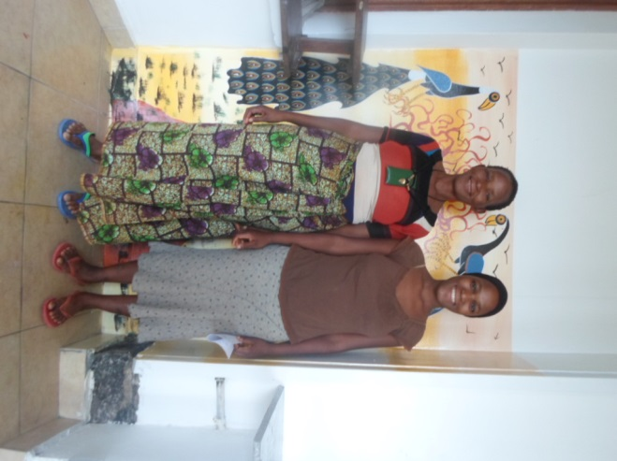
working on the story
PICTURE REPORT
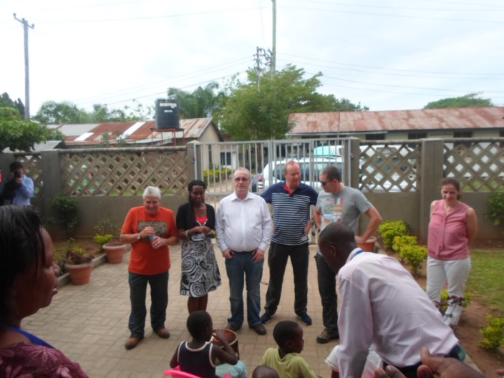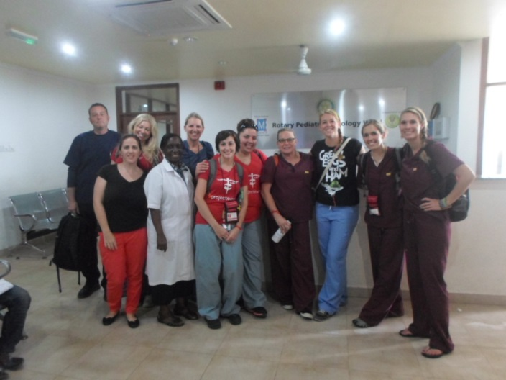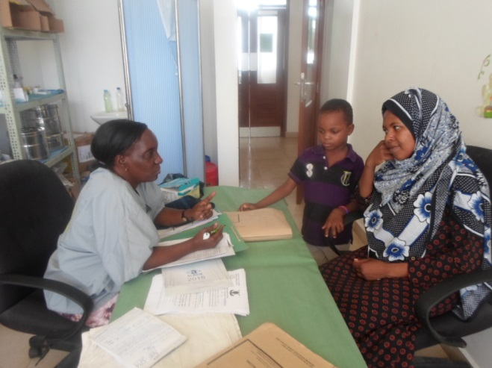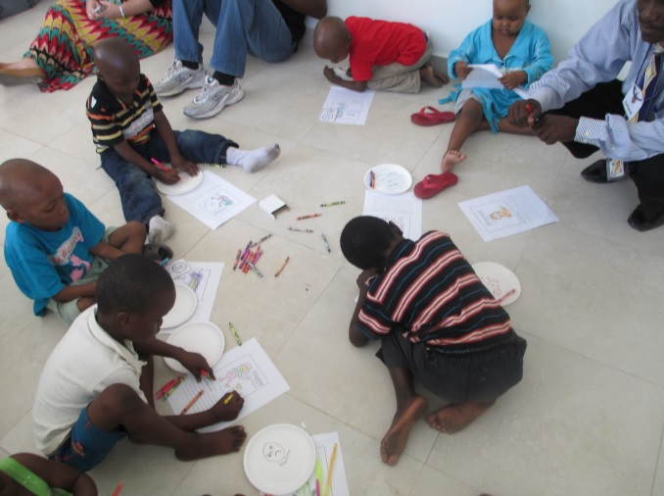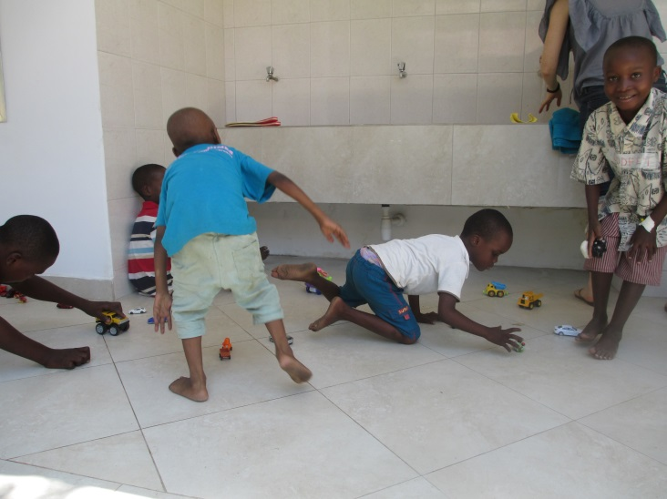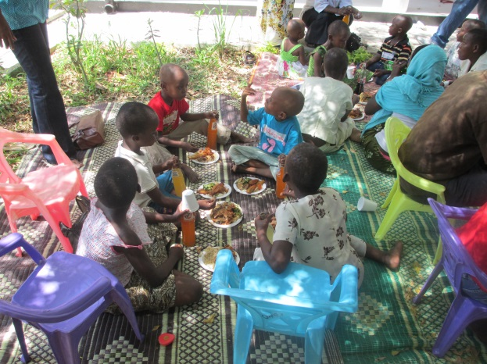

PROGRAMMES IN REVIEW
Programme | Key Achievements
Ujasiri House | - The house has hosted 135 families since January 2014  - The house has become interactive whereby parents from the paediatric cancer ward have access to Ujasiri house kitchen for domestic purposes hence create a sense of home away from home even to ward patients
Education Programme | - 880 children have accessed Play therapy Education Programme in accordance to age  - TLM is still running a MEMKWA programme (Type of education for people with special needs) and we are a recognized center for MEMKWA with full support from the minister of education-Adult section  - The ward school is now fully furnished with necessary equipment to support formal daily school programme  - The sub-programme “Child Life” which aims at providing interactive sessions on pain management, fear and boredom has been continuing by our Play therapy Programme officer who was trained to conduct Child Life Sessions in medical procedure, medical play and pain destruction when undergoing treatment.
Income Generating Activities (IGA) | - 111 parents have been Trained in income and Generating Activities  - More than 300 different products were made by the families which has generated more than Tshs. 800,000, and the profit has been shared amongst the families
Family support programme | - TLM has conducted counselling sessions of diagnosis, disease, treatment and side effects which has proven to be very useful to parents and the children. Its been easier for them to accept the disease presentation, long term treatment and improve their psychological wellbeing. More than 315 new patients were counseled respectively.  - We have provided education on cancer to 216 parents and children through Day Care Programme, which has provided parents and adolescence vast knowledge by providing a chance to discuss issues and ask questions on different type of cancer and its treatment. This include the parents with very sick children
Life skills Programme | - This programme ceased during the second quarter, however more than 16 families were taught different nutritional values of different meals and which ways they could take care of their sick children.
Partnership and Visibility | - TLM is now a member of ICCCPO which is an International Confederation of Childhood Cancer Parent Organizations.  - TLM was able to organize the 3rd International Confederation of Childhood Cancer Parent Organization (ICCCPO Africa) Conference on April 23rd, 2014.

Objective 1:
To improve access to quality non-medical support services for children with childhood cancer and their families
Number of direct beneficiaries: 1,900 children with cancer
Number of indirect beneficiaries: 10,000 + people in childhood cancer families
Indicators | Source | Baseline | January-December 2013
 |  |  | Target | Achievements
% of children accessing the Therapeutic Play Programme on the ward and in Ujasiri House | TLM Database | 65% | 80% | 34%
% of children accessing an age appropriate Education Programme | TLM records | 40% | 50% | 39%
# of children and families staying at the Long Stay Houses | TLM Admissions and Discharge records | 0 | 22 | 83
# of people that receive Cancer Awareness Information | TLM records | 120 | 200 | 531
Outputs | Indicators | Source | Baseline | January-December 2014
 |  |  |  | Target | Achievement
Therapeutic Play Programme and Education Programme is implemented | # of children who are participating in age appropriate play therapy and education programmes | TLM records | 100 | 400 | 880
Family Support Programme is Implemented | # Caregivers who have participated in Income generating activities | TLM records | 80 | 80 | 111
 | # of children and carers who have received counselling | TLM records | 0 | 60 | 256
 | # of carers accessing parent support groups | TLM records | 0 | 20 | 325
 | # of carers accessing life skill training programme | TLM records | 20 | 80 | 16
 | # of carers accessing the transport programme | TLM records | 8 | 60 | 54
 | # of families who went on recreational trips around Dar | TLM records | 0 | 22 | 98
Ujasiri House established | # of Families Accommodated in the hostel | TLM records | 0 | 22 | 135
 | # of parents/caretakers received education on nutritional & diet of children with cancer | TLM records | 0 | 80 | 16
 | # of families that celebrated the festival season | TLM records | 0 | 150 | 19
Cancer Awareness Campaign for health workers is launched | # Publications produced and distributed to the regional centers | Education, Information materials | n/a | 0 | 0
 | # frontline healthcare’s trained |  | n/a | 15
 | # of F4L clubs in schools |  | n/a | 10
 | # media coverage, interviews & campaigns |  | n/a | 3
Cancer Ambassadors Programme is implemented | # of careers trained | TLM records | n/a | 0

Indicator Based Performance Assessment
Not sure what to write

Key Challenges

- Lack of motivation for children and parents to attend the programmes due frequently death’s at the ward.
- Unpredictable participation of parents and children in the programs due to the nature of treatment
- Late disbursement of funds which affect the timely delivery of programs.
- Lack of Teachers who have skills to teach children with disabilities e.g. blind children
- Unpredictable participation of parents and children in the programs due to the nature of treatment
- The increased number of patients in the ward and clinic that gives ward staff limited time to do all the supportive activities.
- Shortage of staff to ensure smooth implementation of the programmes.

Recommendations

- To fill in the positions that were left vacant by the two TLM staff that left.
- Ensure funds are disbursed on time to keep up with programmes deliveries in a timely manner
- Liaise with the municipality in the adult section to ensure they supply us with teachers with skills to teach children with disabilities eg blind children

Sustainability

Not sure what to write

